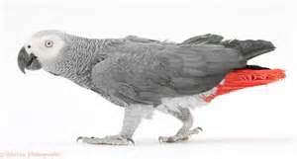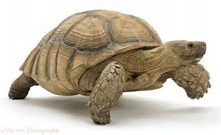
We have outgrown our location and are expanding!! We are looking for another veterinary associate to join us as we move to a larger facility. Exotic Animal Care Center is the only 100% avian and exotic animal hospital in Pasadena, CA, and one of only a few in the state. Seeing avian and exotic pets only allows us to concentrate on the highest level of veterinary care possible. Our clientele is devoted and caring, and interested in thorough diagnostic work ups, proper treatments, and advanced procedures. It is extremely satisfying to work at a hospital where we are able to treat these special species the way they deserve to be treated, and form a gratifying bond with these amazing clients that often come from miles away just to see us. Another perk at our hospital is working with our terrific and highly trained staff. Our technicians are very skilled and are comfortable handling, restraining, performing venipuncture on, caring for and administering treatments to all species. In addition, the technicians are responsible for comprehensive husbandry education and detailed demonstrations for the clients. This frees up the doctors to concentrate on diagnostics and managing cases. Our front desk staff is kind and caring, helping clients and supporting everyone else in multiple functions. We foster a drama-free team approach and provide continuing education for all employees.
Exotic Animal Care Center has all the toys: digital radiology, ultrasound, rigid endoscopy, in house laboratory, therapy laser, high quality dental machine, incubators, and anesthetic monitors. We utilize a nearby facility for CT scans, and use a mobile ultrasound specialist as needed. We currently see 50% rabbits, 15% birds, 15% reptiles, 15% rodents, and a small number of ferrets, pet pigs, wildlife, fish and invertebrates. Each doctor has their special interest, from rabbits to reptiles and acupuncture, and the practice helps support and promote associate interests. Our hospital is well known for treating malocclusion and jaw abscesses in rabbits and rodents, and we receive frequent referrals from local vets and rescue groups.
Pasadena is located in sunny southern California, nestled between Los Angeles, the mountains, ocean and desert. Our location offers numerous cultural amenities and recreational opportunities nearby. Theater, museums, zoos, Hollywood, rock climbing, camping, surfing, wine tasting, the Tournament of Roses Parade and the Rose Bowl – life in southern California offers the best of everything. If you love caring for avian and exotic pets, bonding with their owners, and being able to provide the best medicine available, this is the hospital for you! A minimum of 2 years of veterinary experience with avian and exotic animals is necessary, internship trained ideal. Generous benefit package offered including medical care, 2 weeks paid vacation, 1 week paid sick time, and CE/dues allowance of $1500. Salary is competitive and we use ProSal to help you benefit from your hard work. Please send your resume to Dr. Sari Kanfer at bunnyvet@yahoo.com

