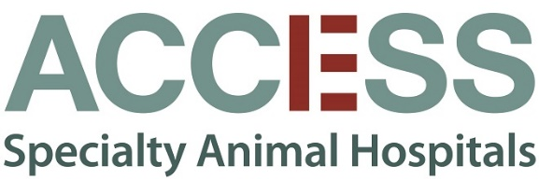

Open Positions:
Avian and Exotics Doctors
We are looking for passionate, detailed, and outgoing Avian and Exotics doctors to join our team at our privately owned Culver City, Woodland Hills and South Bay Hospitals. ACCESS Specialty Animal Hospital is one of the largest, most advanced, compassionate, and progressive veterinary multi-specialty referral hospitals in Southern California.

We’re different. We don’t do corporate red tape. Instead, we do pumpkin carving contests, potlucks, staff support, and innovation in our medical care and management. Does this sound like something you might like? Read on to learn about what we value.

We encourage growth, innovation, and additional training (through in-house RACE approved continuing education courses as well as a competitive conference compensation package). Each specialist is given a full support team including a dedicated assistant and ample technicians to ensure the success of their practice.

ACCESS is currently comprised of emergency/critical care, cardiology, internal medicine, interventional radiology/endoscopy, surgery, nephrology, neurology, urology, and zoological medicine (avian and exotics). Our practice shares a facility with other independently owned and operated specialty practices allowing for direct collaboration with specialists in dentistry, dermatology, oncology, ophthalmology, and radiation oncology. We practice in a rich and rewarding environment where patient care can be optimized and learning is continuous. This type of collaborative medicine is rare outside of a university setting.

To provide the best care possible, we stay apprised of new innovations, and utilize an extensive array of cutting-edge diagnostic, therapeutic, and monitoring equipment. These include a complete laboratory (CBC/Chemistry/ Criticare Express-Nova/Istat/SCA2000, SnapDx, VetTest), monitoring devices (Cardell Max 12/Telemetry/NIBP/ Invasive BP/telemetry), digital radiography, color flow Doppler ultrasound (GE Logiq S7, P6, Sonoscape portable ultrasound and Phillips CX50 cardiac ultrasound), OEC 9800 & 9900 fluoroscopy with neuro vascular package, 16 slice helical CT, and 1.5T MRI. We have pulmonetics critical care ventilator at each hospital. We are also equipped with complete endoscopic, laparoscopic, and thoracoscopic instrumentation. We are always willing to expand in different directions and explore new therapies.

An ideal candidate will exemplify our guiding principles of Quality, Integrity, Compassion, and Service. They will have strong communication skills, an energetic attitude, empathy, and enthusiasm for helping clients and patients alike. They will excel at collaborating with their co-workers, our referring veterinarians, and our clients.

Essential job functions will be provided during the selection process. We offer an excellent salary and benefits package. Travel compensation for your interview will be provided by ACCESS.

Please send your CV attention to our Chief of Staff, Richard Mills, DVM, DACVECC at rmills@accessvets.com.

