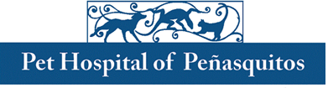

Reptile and Amphibian Practice Residency
The Pet Hospital of Penasquitos is a small and exotic animal hospital in beautiful San Diego. Drs. Boyer and Mendez are looking for an outstanding resident to become an ABVP diplomate in Reptile and Amphibian Practice. San Diego boasts an average year-round temperature in the low 70s which allows for a diverse reptile population. This is a three-year residency that emphasizes reptiles, but includes dogs, cats, small mammals, birds, and amphibians.
A rotating internship or a minimum of one year of practice experience is required, as well as licensure in California. Corona virus vaccination highly encouraged. This residency includes a 4-day work week, $60K salary, paid continuing education, holidays, and vacation, plus additional benefits including half health insurance. Please submit a cover letter briefly explaining your desire to become a Reptile and Amphibian Specialist, CV/Resume, and 3 letters of recommendation to DrTomBoyer@hotmail.com. Educate us while you learn.

9888 Carmel Mountain Rd, Ste F, San Diego, CA 92129
(858) 484-3490 Fax (858) 484-3499 www.pethospitalpq.com www.facebook.com/pethospitalpq

