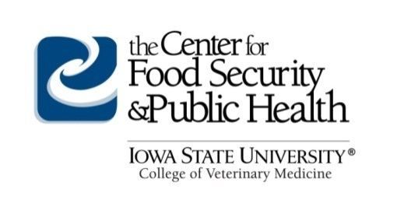
FOR IMMEDIATE DISTRIBUTION
Source: Center for Food Security and Public Health
College of Veterinary Medicine
Iowa State University
Zoonoses@iastate.edu
Press Contact: Connie Scovin, communications: cscovin@iastate.edu or Telephone 515-520-9200

Zoonotic Disease Online Course Offered in October

Ames, IA – Recent outbreaks of plague, tularemia and increasing incidents of rabies exposure highlight the importance of zoonotic disease education for veterinarians, physicians, and public health professionals. Prevention and response efforts will require a One Health approach. The Center for Food Security and Public Health (CFSPH) at Iowa State University College of Veterinary Medicine will offer a web-based course, Zoonoses: Protecting People and Their Pets, October 19 – November 27, 2016.

This course provides an excellent opportunity for medical and public health professionals and students to refresh and gain knowledge of key zoonotic diseases of companion animals. The course is web-based and includes lessons, case studies, a discussion board, and online resources to assist course participants in educating clients about zoonotic disease prevention. The course is approved for 10 hours of continuing education for veterinarians or veterinary technicians in jurisdictions which recognize AAVSB RACE approval.

“Companion animals play an important role in people’s lives,” said Dr. Glenda Dvorak, DVM, MPH, DACVPM, course instructor, Assistant Director, CFSPH. Dr. Dvorak emphasizes that “Partnerships between medical, public health and veterinary professionals are needed to raise awareness, enhance detection, and promote prevention of zoonotic diseases to protect the health of people and pets.”

The cost to register for the course is $125, which includes a copy of the companion textbook (a $70 value).

To find out more and to register, visit http://www.cfsph.iastate.edu/Zoonoses-Course/ or http://zoonoses.info

About the Center for Food Security and Public Health
The Center for Food Security and Public Health (CFSPH) is nationally and internationally recognized for providing educational materials and animal disease information. The CFSPH was established in 2002 through funding from the Centers for Disease Control and Prevention (CDC) to increase national and international preparedness for accidental or intentional introduction of diseases that threaten food production or public health. The CFSPH website (www.cfsph.iastate.edu) is the Number One result on Google searches for “animal disease information,” with more than 450,000 visits annually.

-End-

