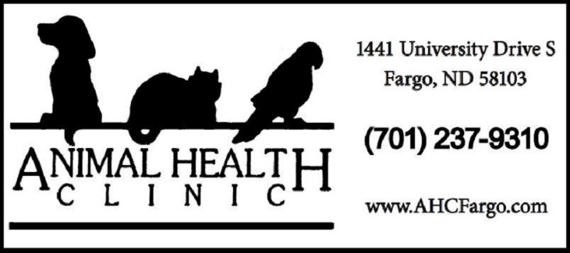
Associate Veterinarian
The Animal Health Clinic in Fargo, North Dakota is seeking a sixth veterinarian with exotic experience to join our small animal practice. At least 3 years of experience with reptiles, birds, and exotics is preferred. Great hours with no on-call or after-hours emergencies.
Since 1972, our clients choose our clinic for the premium quality care they receive from our entire staff. We have been AAHA accredited since 1979, and maintain our high-quality care with ultrasound, endoscopy, therapy laser, stem cell therapy, Fear Free certification, and digital radiography.
Competitive salary will depend on experience. Terrific benefits are offered including: 100% paid family health, dental, and vision insurance; 401(k) with up to 4% match; profit sharing; paid time off; paid association dues/licensing/liability insurance; paid continuing education; employee discount.
To apply please email resume and cover letter to natalie@ahcfargo.com. If you would like more information about the clinic, the position, or what Fargo, ND has to offer, please call Natalie- Practice Manager, at 701-237-9310.

