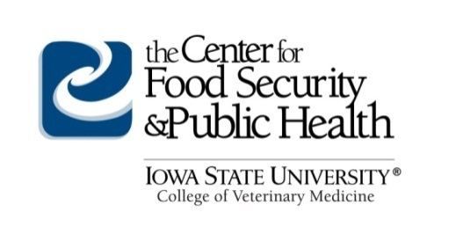
FOR IMMEDIATE DISTRIBUTION
Source: Center for Food Security and Public Health
College of Veterinary Medicine
Iowa State University
ade@iastate.edu
Press Contact: Connie Scovin, communications: cscovin@iastate.edu or Telephone 515-520-9200

New Animal Disease Emergency Online Course Helps Ensure Rapid and Coordinated Response

Veterinary and animal health responders learn their roles in livestock or poultry emergencies

Ames, IA –The impact of an animal disease outbreak will have serious consequences for producers, as well as local and state economies. Ensuring that all responders understand the impact, the terminology used, and actions required will produce a more rapid and coordinated response.

The Center for Food Security and Public Health (CFSPH) at Iowa State University College of Veterinary Medicine is now offering a web-based course, Animal Disease Emergencies: Understanding the Response. The cost for the course is $100. To find out more and to register, visit http://www.cfsph.iastate.edu/ADE-Course/.

This web-based, awareness level course is designed for anyone who may be involved in an animal disease response – veterinary and animal health responders, livestock or poultry producers and industry groups, wildlife managers and officers. Traditional responders, including emergency managers, law enforcement, firefighters, public health, will also benefit and learn about roles they may have during a response.

Dr. Glenda Dvorak, DVM, MPH, DACVPM, course instructor, Assistant Director, CFSPH, explains, “The response to a livestock or poultry disease outbreak will involve the coordination and collaboration of a number of professions, industries and agencies. This course introduces key concepts related to the response for a livestock or poultry disease emergency. It highlights the actions needed to detect, contain and control these diseases, to better prepare responders for their tasks during the response.”

The course is approved for 4.0 hours of veterinary continuing education credit in jurisdictions which recognize AAVSB RACE approval.

About the Center for Food Security and Public Health
The Center for Food Security and Public Health (CFSPH) is nationally and internationally recognized for providing educational materials and animal disease information. The CFSPH was established in 2002 through funding from the Centers for Disease Control and Prevention (CDC) to increase national and international preparedness for accidental or intentional introduction of diseases that threaten food production or public health. The CFSPH website (www.cfsph.iastate.edu) is the Number One result on Google searches for “animal disease information,” with more than 450,000 visits annually.

-End-

