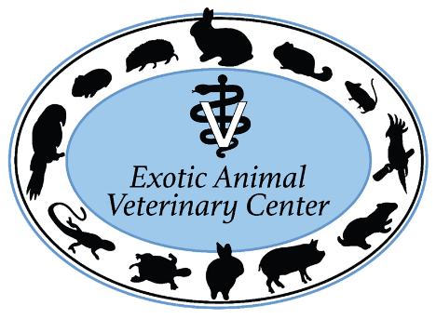
Exotic Animal Veterinary Center is a 4 ½ doctor, 100% avian and exotics hospital in sunny Pasadena, CA. We are extremely busy and need to add another associate. We see about 40% rabbits, 20% birds, 20% reptiles, and 20% rodents, ferrets, wildlife, pot belly pigs, hedgehogs, sugar gliders and fish. We practice high quality, highly compassionate medicine. We believe in thorough work ups and cutting-edge veterinary treatments, and we provide intensive care hospitalization. We have a great reputation in the area and get constant referrals from other veterinarians and rescue groups. Our clientele is devoted and caring, and interested in comprehensive diagnostic work ups, proper treatments, and advanced procedures. It is extremely satisfying to work at a hospital where we can treat these special species the way they deserve to be treated and form a gratifying bond with these amazing clients that come from miles away just to see us.
We have all the bells and whistles: digital radiology, in house Abaxis CBC and chemistry machines, urine protein/creatinine ratio analyzer, gram stain, ultrasound machine, therapy laser, rigid endoscope, tonopen, incubators, Doppler blood pressure, multi-parameter anesthetic monitors, ventilator, high quality dental machine and all the rabbit/rodent dental instruments you could ask for. We utilize a nearby facility for CT scans and radiation, and use a mobile ultrasound specialist as needed.
We have cultivated a team-based, positive and supportive environment. We have 2-3 doctors working every shift, which means that there is always another exotics-experienced veterinarian to discuss cases with. We work four 10hr shifts, which allows enough time off for a personal life. Another perk at our hospital is working with our terrific and highly trained staff. Our technicians are very skilled and are comfortable handling, restraining, intubating, performing venipuncture on, caring for and administering treatments to all species. In addition, the technicians are responsible for comprehensive husbandry education and detailed demonstrations for the clients. This frees up the doctors to concentrate on diagnostics and managing cases.
Pasadena is located in sunny southern California, nestled between Los Angeles, the mountains, ocean and desert. Our location offers numerous cultural amenities and recreational opportunities nearby. If you are passionate about caring for avian and exotic pets, bonding with their owners, and being able to provide the best medicine available, this is the hospital for you!
Salary is competitive and based on experience. Internship or 1 year of exotic veterinary experience preferred, willing to consider other applicants. Benefits include generous signing bonus, medical and dental insurance, CE/Dues allowance, paid vacation and paid CE days, and discounted pet services. We encourage and support special interests and CE and will cover the costs of ultrasound training, acupuncture certification and specialty board certification. Please send your CV to Dr. Sari Kanfer at bunnyvet@yahoo.com

