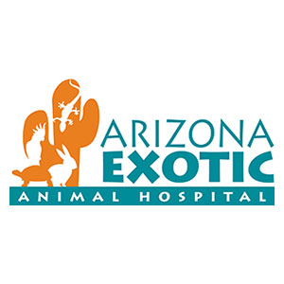
744 N. Center St. Ste 101, Mesa AZ 85201 480-275-7017
20040 N. 19th Ave. Ste C, Phoenix AZ 85027 623-243-5200
4951 E. Grant Road #103, Tucson AZ 85712 520-305-0055
www.azeah.com

EXOTIC PET MEDICINE AND SURGERY INTERNSHIP
Arizona Exotic Animal Hospital is a growing exotic pet, zoo, and wildlife exclusive hospital with 3 offices in Arizona. We have two internship positions available starting June 15th, 2020. Our team of well-trained doctors and staff provide high quality veterinary medical and surgical care to our unique and diverse patients. We do not see dogs and cats allowing us to focus more on the special individual needs of the variety of species we work with. We maintain a happy work environment where everyone enjoys coming to work and working together to accomplish both personal and professional growth and greatness. We are seeking interns with at least one year experience in a private practice or a small animal internship. Exceptions may be made if an applicant shows a strong interest with experience in exotic animal medicine. Compensation and benefits include:
• Base salary $36,000/yr.
• Additional compensation paid for after-hours emergencies seen.
• 7 days personal paid time off.
• Arizona exam and license fee reimbursed upon passing.
• $1000 continuing education budget and 3 days paid time off for CE.
• 1 year membership to ARAV, AEMV, and AAV paid.
• Professional liability insurance provided.
• Up to $250/month health insurance reimbursement.
Please see our program information and apply on virmp.org

