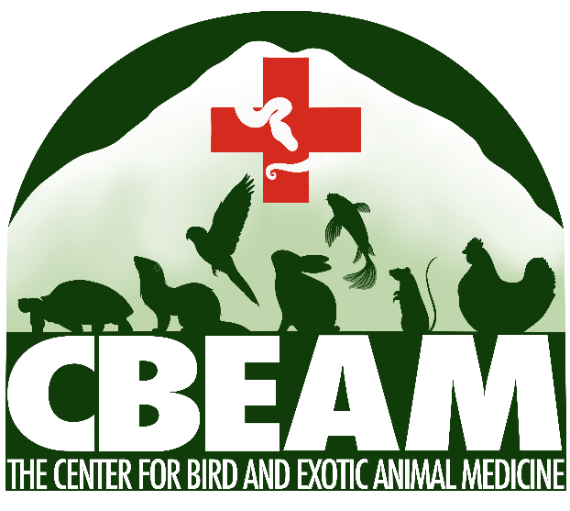
The Center for Bird and Exotic Animal Medicine (CBEAM) is searching for board-certified or board-eligible exotic or emergency/critical care specialists to join our team.

About Us:
- Website: www.theexoticvet.com
- Located near Seattle, WA
- Exotics-exclusive (primarily pet exotics with some zoo species/wildlife)
  - Emergency and routine preventative care offered
  - Staffed 24/7 with veterinarians and support team
  - Rapidly growing practice
    - Nine associate veterinarians, one resident, and three interns currently employed
  - On-site CT, fluoroscopy, digital radiography, ultrasound, endoscopy, therapy laser, and specialized surgical equipment (radiosurgery, Ligasure, hemoclips, etc.).
  - Access to other local clinical specialists (oncology, cardiology, surgery, etc.)
- High standards of medicine, client care, and patient care
  - Teaching and referral hospital
    - Training provided for veterinary interns/residents, veterinary externs, and veterinary technician externs
    - Twice weekly virtual/in-person continuing education rounds to ensure doctors and staff are up to date on the latest developments in exotic medicine
  - Financial support and mentorship provided for doctors who are working towards board certification
  - Multiple CBEAM doctors regularly publish in peer reviewed journals and present at national conferences annually
- Commitment to advancing team wellness
  - Creating and maintaining a positive team environment for all staff
  - Supportive leadership with focus on team culture, cohesion, and development
  - Inclusive community that embraces diversity and is an equal opportunity employer
  - Focus on mental health awareness and support

Job requirements:
- Board certification or board-eligibility in ONE of the following:
  - American College of Zoological Medicine (ACZM)
    - Zoological Medicine OR Zoological Companion Animal Medicine
  - American Board of Veterinary Practitioners (ABVP)
    - Exotic Companion Mammal, Avian, OR Reptile/Amphibian medicine
  - European College of Zoological Medicine (ECZM)
    - Avian, Herpetology, OR Small Mammal Medicine
  - American College of Veterinary Emergency and Critical Care (ACVECC)
- Veterinary degree from AVMA-accredited veterinary college
- Ability to obtain veterinary licensure from Washington State and maintain it in good standing
- Strong commitment to advancing exotic medicine
- Excellent client and interpersonal communication skills
- Organization and record-keeping skills
- Act with integrity and compassion
- Enthusiasm for teaching (and learning from) other veterinarians and team members
- Willingness to follow Team Agreements, which include (among others):
  - Assume good intent
  - Be supportive
  - Encourage growth
  - Prioritize physical and mental health
  - Promote and maintain positive energy
  - Focus on solutions
  - Ask for help
Benefits:
- Competitive, experience-based salary with production bonuses
- Signing, moving, and retention bonuses
- Flexible scheduling (3 or 4 day work weeks)
  - Overnight, swing, and day shifts available; full and part-time positions available
  - Time built into schedule for charting/client call backs/study
- Medical, dental, vision, disability (short and long term), and life insurance
  - Access to mental health wellness resources
- 4 weeks annual PTO
- Professional dues, PLIT, and licensing reimbursement
- Continuing Education stipend
  - Additional PTO for conference attendance
- 401K with employer matching available
- Pet care discounts
- Family friendly

Location
CBEAM is located about 20 miles north of Seattle, WA, and experiences temperate weather year round. Within a 2-hour drive, our veterinarians can access pristine forests, majestic mountains, beautiful oceans, charming islands, and snowy ski resorts. Western Washington offers an abundance of gorgeous scenery and unlimited coffee shops. For the city dweller, there is a vibrant music/art scene, delicious/diverse food choices, multiple professional sports teams, and museums of all types. There are also four AZA-accredited zoological facilities within easy driving distance. For the outdoor enthusiast, there is plenty of hiking and waterfront access for beachcombing, kayaking, scuba diving, etc. Our megafauna include orcas, pinnipeds, grizzly bears, and elk, and WA is committed to good ecological management of our environment/wildlife. This is a fast growing area with a booming economy, top-notch educational opportunities, and expanding access to public transportation. It is a lovely place to live and explore.
Interested candidates should send their CV/resume and
two employment references to cbeammdvms@gmail.com.

