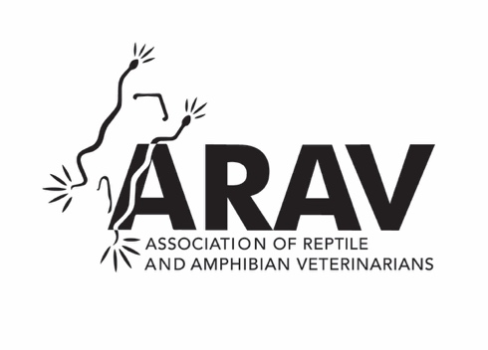

EXTERNSHIP FORM

LOCATION:
Institution/hospital name: Avian and Exotic Animal Hospital of Georgia
street address: 118 Pipemakers Circle, Suite 110
city/state/country/zip: Pooler, GA 31322

CONTACT INFO:
Name: Stacey Leonatti Wilkinson, DVM, DABVP (Reptile and Amphibian) | Phone:912-348-3924
Title: Veterinarian and Owner | Fax: 912-348-3934
Email: drw@avianexotichospital.com | Website:www.avianexotichospital.com

DESCRIPTION
Avian & Exotic Animal Hospital of Georgia is dedicated exclusively to the care of exotic pets. Our caseload is approximately 40% exotic companion mammal, 35% avian, and 25% reptile. Students will observe and work closely with any of our three veterinarians, one of which is a board certified specialist in reptile and amphibian medicine.

APPLICATION DEADLINE
None specific, though many externships are booked 6-18 months in advance, so the more advance notice the better for availability as we can only accommodate 1 student at a time. Email is preferable for requests.

HOUSING AVAILBILITY and TRANSPORTATION
None provided

LIABILITY AND HEALTH INSURANCE
Student will need to provide own liability insurance

